# INTRODUCTION

* 1. Overview

A visa slot management project is a system that is used to track and manage the availability of visa slots, which are appointments that are required for certain visa applications. It might be used by a government agency or a visa processing center to schedule and manage appointments with applicants.

A brief description about your project

A visa slot management project is a system that is used to track and manage the availability of visa slots, which are appointments that are required for certain visa applications. It might be used by a government agency or a visa processing center to schedule and manage appointments with applicants.

* 1. Purpose
  2. A visa slot management project is a system that is used to track and manage the availability of visa slots, which are appointments that are required for certain visa applications.

The use of this project. What can be achieved using this.

* Its symplify the process
* Its take lower processing time
* Helps to young generations

1. **Problem Definition & Design Thinking**
   1. Empathy Map

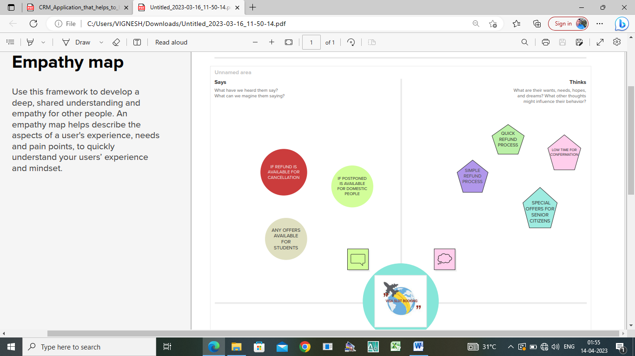

* 1. Ideation & Brainstorming Map

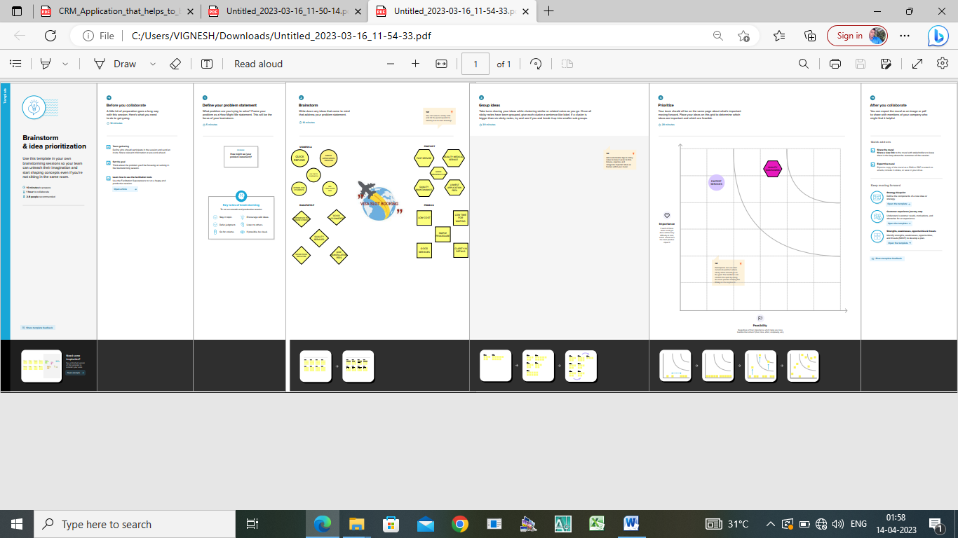

# RESULT

* 1. Data Model:

|  |  |
| --- | --- |
| **Object name** | **Fields in the Object** |
| obj1  Passport | |  |  | | --- | --- | | Field label | Data type | | Full name | Text | | Passport number | Number | | Contact number | Number | | Permanent address | Text | |
| obj2  Visa slots | |  |  | | --- | --- | | Field label | Data type | | Location | Text | | Time | Number | | Passport number | Master | | Visa slot number | Number | |
| Obj 3  Payment | |  |  | | --- | --- | | Field label | Data type | | Payment mode | Text | | Card number | Number | | Transaction id | Auto number | | Cancel Transaction | Text | | Visa slot number | Master | |
| Obj 4  Rechedule/cancel | |  |  | | --- | --- | | Field label | Data type | | Passport number | Master | | Location | Text | | Time | Number | | Cancel | Text | | Status | Text | |

## Activity & Screenshot

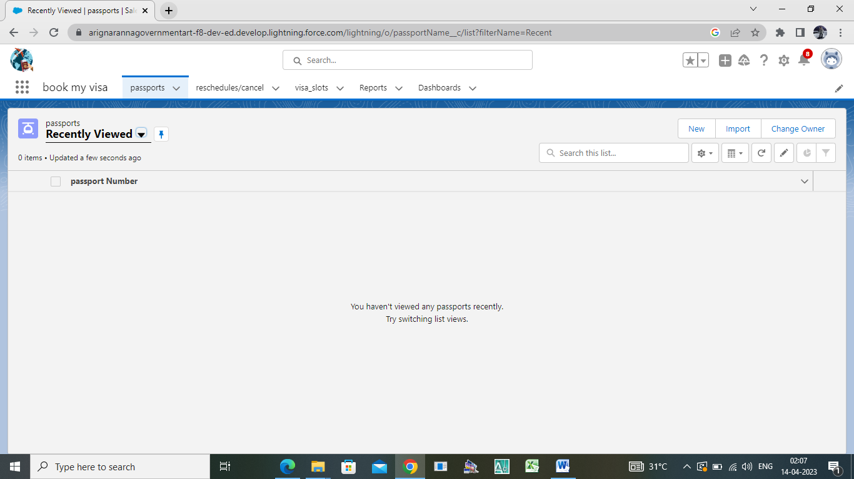

## Trailhead Profile Public URL

**Team Lead -** [**https://trailblazer.me/id/**](https://trailblazer.me/id/ot3)**vigneshmuskme**

**Team Member 1 – [https://trailblazer.me/id/](https://trailblazer.me/id/ot3)gprabu1**

**Team Member 2 -** [**https://trailblazer.me/id/**](https://trailblazer.me/id/ot3)**tprathipt**

**Team Member 3 –**

[**https://trailblazer.me/id/**](https://trailblazer.me/id/)**ragup11**

# ADVANTAGES & DISADVANTAGE

List of advantages

* designed to help you can easily booking visa slots.
* It helps you manage all the process.

List of disadvantages

* It not much supported for uneducated peoples
* If event data will be changed frequently means, difficult to design

# APPLICATIONS

* Arranging National and International level trips.
* In self plan the trip schedules

1. CONCLUSION
   1. A visa slot management project is a system that is used to track and manage the availability of visa slots, which are appointments that are required for certain visa applications.

# FUTURE SCOPE

It can be developed in different languages and pictorial basis even for understanding uneducated peoples.